

**Qualcomm Car-to-Cloud Platform**

**IoT Wrapper Usage Document**

**Version No.1.0**

|  |  |  |  |
| --- | --- | --- | --- |
|  | **Prepared By / Last Updated By** | **Reviewed By** | **Approved By** |
| **Name** | Jean Johnson |  |  |
| **Role** | Developer |  |  |
| **Signature** |  |  |  |
| **Date** | May 5, 2021 |  |  |

**Table of Contents**

1 Project Overview 3

1.1 Interface Projects 3

1.2 Implementation Projects 3

2 Class Diagram 4

2.1 Aws IoT Core Thing Management 4

2.2 Device MQTT Connection to Aws IoT Core 4

3 Interface Method Details 5

4 Usage Details 6

4.1 Dependencies 6

4.2 Aws IoT Core Thing Management 7

4.2.1 Create Thing 7

4.2.2 Delete Thing 7

4.3 Device MQTT Connection To Aws IoT Core 8

4.3.1 Processor to process message once Subscribed 8

4.3.2 Communication to IoT Core 8

5 Git Repositories 9

# Project Overview

We have developed an interface adapter for IoT Gateway thing management and for Device Communication to IoT Gateway, so that applications, can consume it for Device management specific operations and for communication to IoT Gateway.

## Interface Projects

**IoT Gateway Thing Management**

1. Create Thing: Create a new Device will all required resources
2. Delete Thing: Delete a Device and all associated resources

**Device Connection to IoT Gateway**

1. Connect to IoT Gateway

2. Publish to topic

3. Subscribe to topic

4. Disconnect from IoT Gateway

5. Processor Interface: Process messages received from IoT

## Implementation Projects

AWS Implementation is provided for the above said Interfaces to carry out various operations in IoT Core as well to connect and communicate with AWS IoT Core using the MQTT Protocols.

**AWS IoT Core Thing Management**

1. Create Thing
   1. Create AWS Thing with name *{device-id}*
   2. Create Policy from template
      1. Client Id: *{device-id}*
      2. Subscribe Topic Format: */device/{device-type}/{device-id}/in*
      3. Publish Topic Format: */device/{device-type}/{device-id}/out*
   3. Register Certificate
   4. Attach Policy to Certificate
   5. Attach Thing to Certificate
   6. Activate Certificate
2. Delete Thing
   1. Detach Thing from Certificate
   2. Detach Policy from Certificate
   3. Delete Thing
   4. Delete Policy

**Device MQTT Connection to AWS IoT Core**

1. Create MQTT Client using Certificate
2. Connect to IoT Core
3. Publish to Topic
4. Subscribe to Topic
5. Forward message to the Processor
6. Disconnect from IoT Core

# Class Diagram

## Aws IoT Core Thing Management

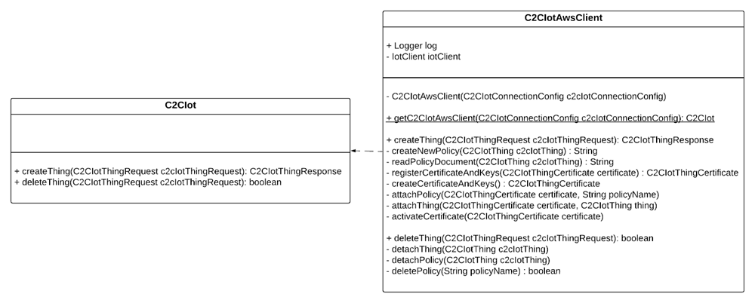

## Device MQTT Connection to Aws IoT Core

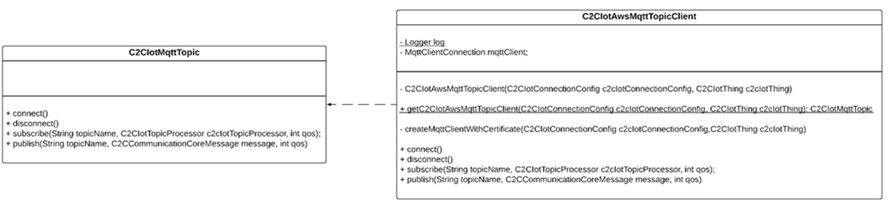

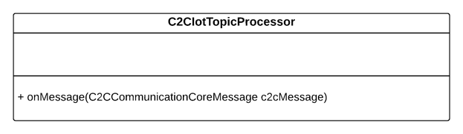

# Interface Method Details

|  |  |  |  |
| --- | --- | --- | --- |
| **Method Name** | **Purpose** | **Input** | **Output** |
| **C2CIot** | Interface for IoT Gateway thing management | | |
| **createThing()** | Method to create a new Device and all associated resources | C2CIotThingRequest containing :  1. Device Id  2. Device Type  3. Certificate (optional) | C2CIotThingResponse |
| **deleteThing()** | Method to delete a Device and all associated resources | C2CIotThingRequest containing:  1. Device Id  2. Certificate | boolean |

|  |  |  |  |
| --- | --- | --- | --- |
| **Method Name** | **Purpose** | **Input** | **Output** |
| **C2CIotMqttTopic** | Interface to perform subscribe and publish activities using an MQTT Client | | |
| **connect()** | Establish connection to the IoT Gateway |  |  |
| **disconnect()** | End connection with the IoT Gateway |  |  |
| **subscribe()** | Subscribe to a topic | Topic Name,  C2CIotTopicProcessor,  Quality of Service |  |
| **publish()** | Publish to a topic | Topic Name,  C2CCommunicationCoreMessage,  Quality of Service |  |

|  |  |  |  |
| --- | --- | --- | --- |
| **Method Name** | **Purpose** | **Input** | **Output** |
| **C2CIotTopicProcessor** | Interface to process messages received on Subscription to IoT Gateway | | |
| **onMessage ()** | Method to process data received from IoT Gateway | C2CCommunicationCoreMessage |  |

# Usage Details

## Dependencies

**IOT MQTT Interface**

<dependency>

<groupId>com.c2c.iot.mqtt</groupId>

<artifactId>c2c_base_iot_mqtt_intf</artifactId>

<version>0.0.1-SNAPSHOT</version>

</dependency>

**IOT MQTT AWS implementation**

<dependency>

<groupId>com.c2c.c2cawsiotmqtt.client</groupId>

<artifactId>c2c_base_iot_mqtt_aws_impl</artifactId>

<version>0.0.1-SNAPSHOT</version>

</dependency>

**IOT Interface**

<dependency>

<groupId>com.c2c.iot</groupId>

<artifactId>c2c_base_iot_intf</artifactId>

<version>0.0.1-SNAPSHOT</version>

</dependency>

**IOT AWS implementation**

<dependency>

<groupId>com.c2c.c2cawsiot</groupId>

<artifactId>c2c_base_iot_aws_impl</artifactId>

<version>0.0.1-SNAPSHOT</version>

</dependency>

**Base Common Project**

<dependency>

<groupId>com.c2c</groupId>

<artifactId>c2c_base_common</artifactId>

<version>0.0.1-SNAPSHOT</version>

</dependency>

## Aws IoT Core Thing Management Sample Code

### Create Thing

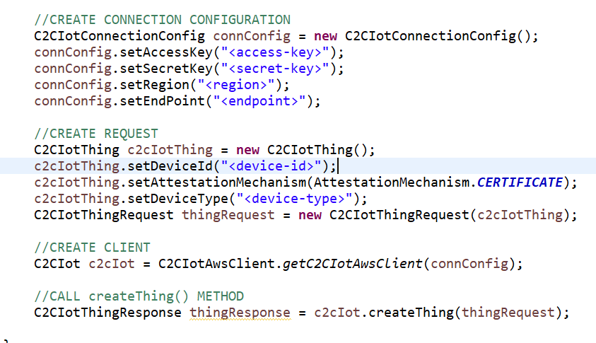

### Delete Thing

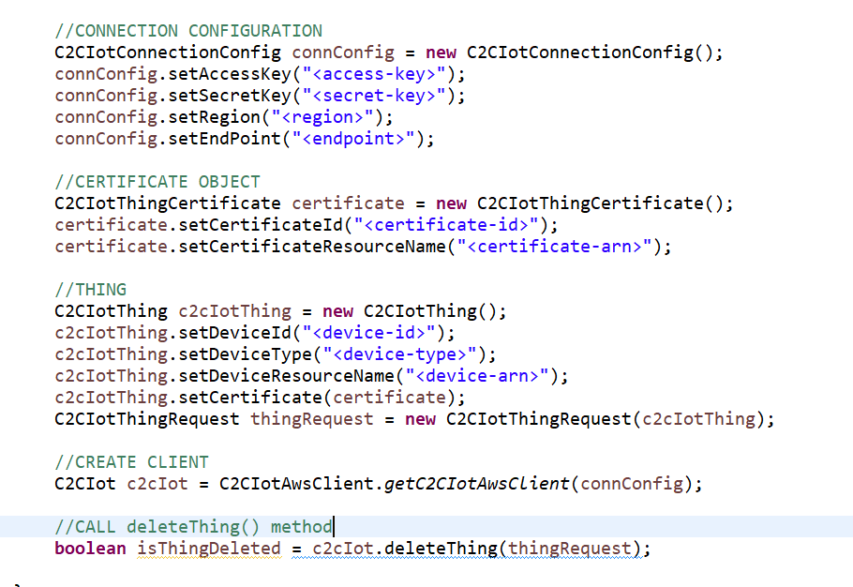

## Device MQTT Connection To Aws IoT Core Sample Code

### Processor to process message once Subscribed

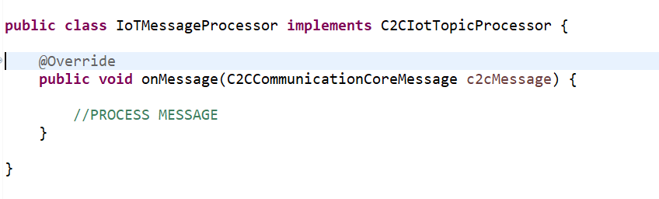

### Communication to IoT Core

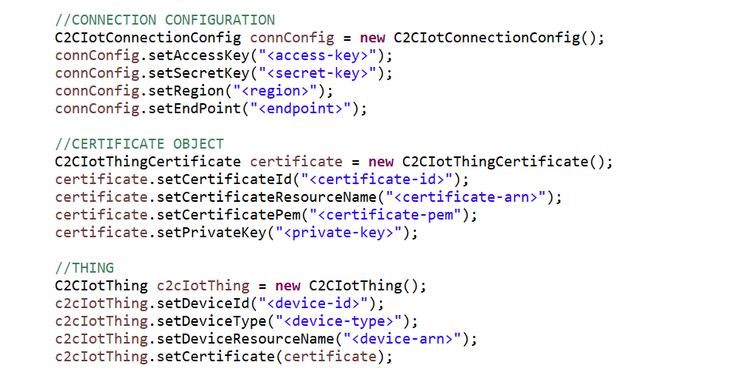

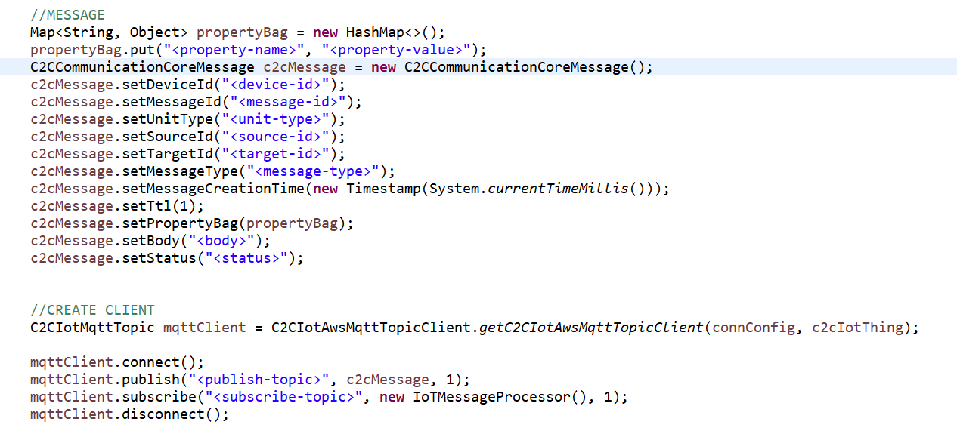

# Git Repositories

1. IOT MQTT Interface:

https://github.com/Github-Enterpirse-India/c2c_base_iot_mqtt_intf/tree/develop

1. IOT MQTT AWS implementation:

https://github.com/Github-Enterpirse-India/c2c_base_iot_mqtt_aws_impl/tree/develop

1. IOT Interface:

https://github.com/Github-Enterpirse-India/c2c_base_iot_intf/tree/develop

1. IOT AWS implementation:

https://github.com/Github-Enterpirse-India/c2c_base_iot_aws_impl/tree/develop

1. Base Common Project:

https://github.com/Github-Enterpirse-India/c2c_base_common/tree/develop

1. Sample Application:

https://github.com/Github-Enterpirse-India/c2c_base_iot_sample_client/tree/develop